CURRICULUM VITAE

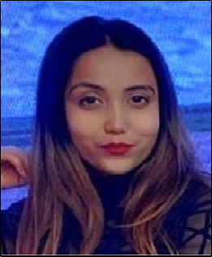

# Bhoomi naik

Flat no -- 101 building 24 Street 13 discovery garden UAE  
Contact Number +91-8146733870 , +91-8795110007

Email id : [bhuminaik56@gmail.com](mailto:bhuminaik56@gmail.com)

***Area of Interest*** *— F&B Service*

***EDUCATION:***

|  |  |  |  |
| --- | --- | --- | --- |
| ***Qualification/Degree*** | ***School/College*** | ***University or Board*** | ***Year*** |
| *B. Sc. (H&HA)* | *Chitkara School of Hospitality, Rajpura, Punjab* | *NCHMCT NOIDA & IGNOU NEW DELHI* | *2016-2019* |
| *Class XII* | *Tagore senior secondary*  *school,mayapuri,new Delhi* | *CBSE* | *2015-2016* |
| *Class X* | *National institute of open schooling,newdelhi* | *CBSE* | *2013-2014* |

# TRAINING& PROJECTS:

***Training:***

***17 weeks Industrial Training from Le Meridien, New Delhi(27 June 2017 —20 October 2017) Job Experience:***

***Currently Working in Five Palm Jumeriah Village as an F&B Hostess From 17 Feb, 2022 Worked in St.Regis Mumbai as an F&B Associate from July 1st, 2019 to 15 April, 2021***

***Worked at Seven Kitchens for 12 months***

***Worked at The Sahib Room & Kipling Bar for 6 months***

***Worked at By The Mekong for 2 months***

***Skills acquired:***

Service

Bar knowledge

Tackle with the guest issues and complaints Up selling of our product

Cover Set up

Order taking from the guest Use of Micros

Billing & Settlement

# Projects:

Served the esteemed guests who visited the University campus on various occasions Participated in valedictory function as a dance co-ordinater in the college Participated in hotel 4th anniversary function as a dance coordinator.

# ACHIEVEMENTS:

Received certificate for participation in service and valedictory function Received appreciation for organizing the theme lunch in the college Received appreciation for participating in the cultural events of the college Received appreciation from the guest in guest voice.

Received appreciation from hotel to choreograph dance for Virtual Diwali occasion 2020.

# PROFESSIONAL SKILLS:

Good Interpersonal Skills Team Player/Management Multi Tasker

Leadership Adaptable

# INTEREST & HOBBIES:

Dancing Calligraphy Painting/ Drawing

# PASSPORT DETAILS

Passport Number: T1806365

Date of Issue : 10/07/2019

Date of Expiry : 09/07/2029

Place of Issue : Lucknow

# (BHOOMI NAIK)

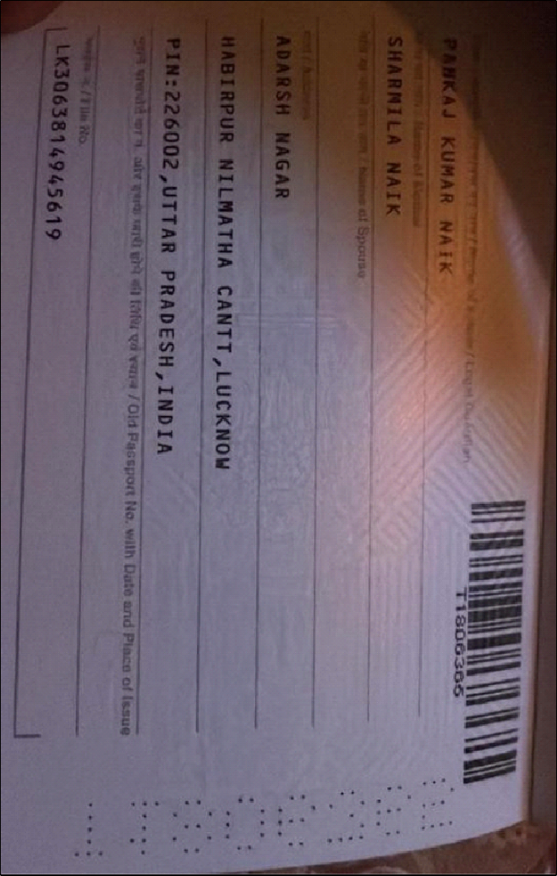

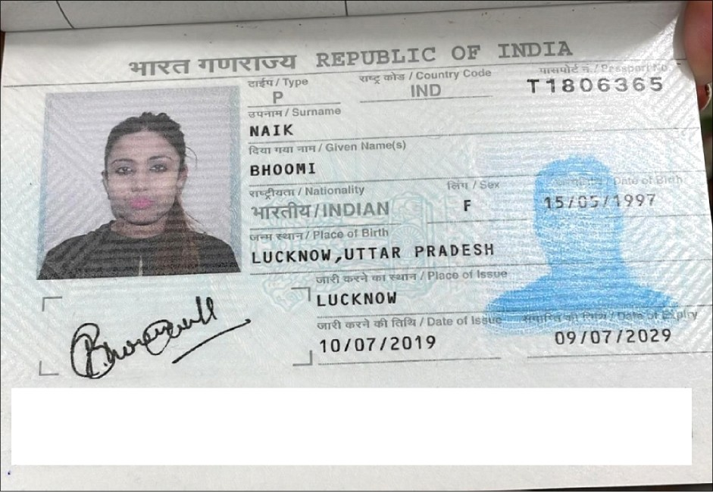

<znanAIK<<B*^ * ************* **** *** **

/ 1 $$§3 65<2 I N A 97O5 157 FZ 907 099'4'4*•‘¥ ******* * *

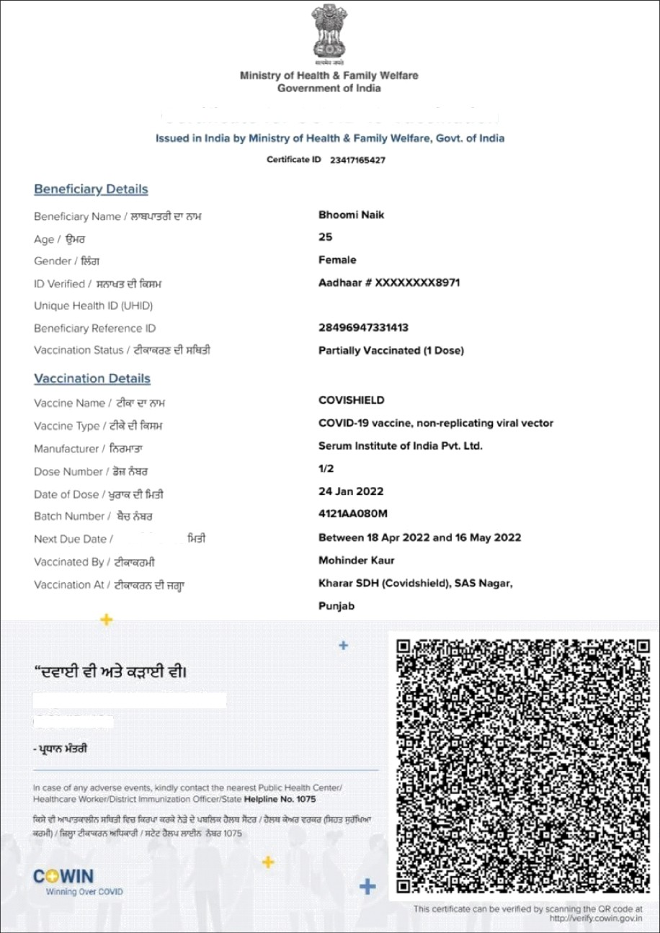

Certificate for COVID-19 Vaccination

Together, India will defeat COVID-19"